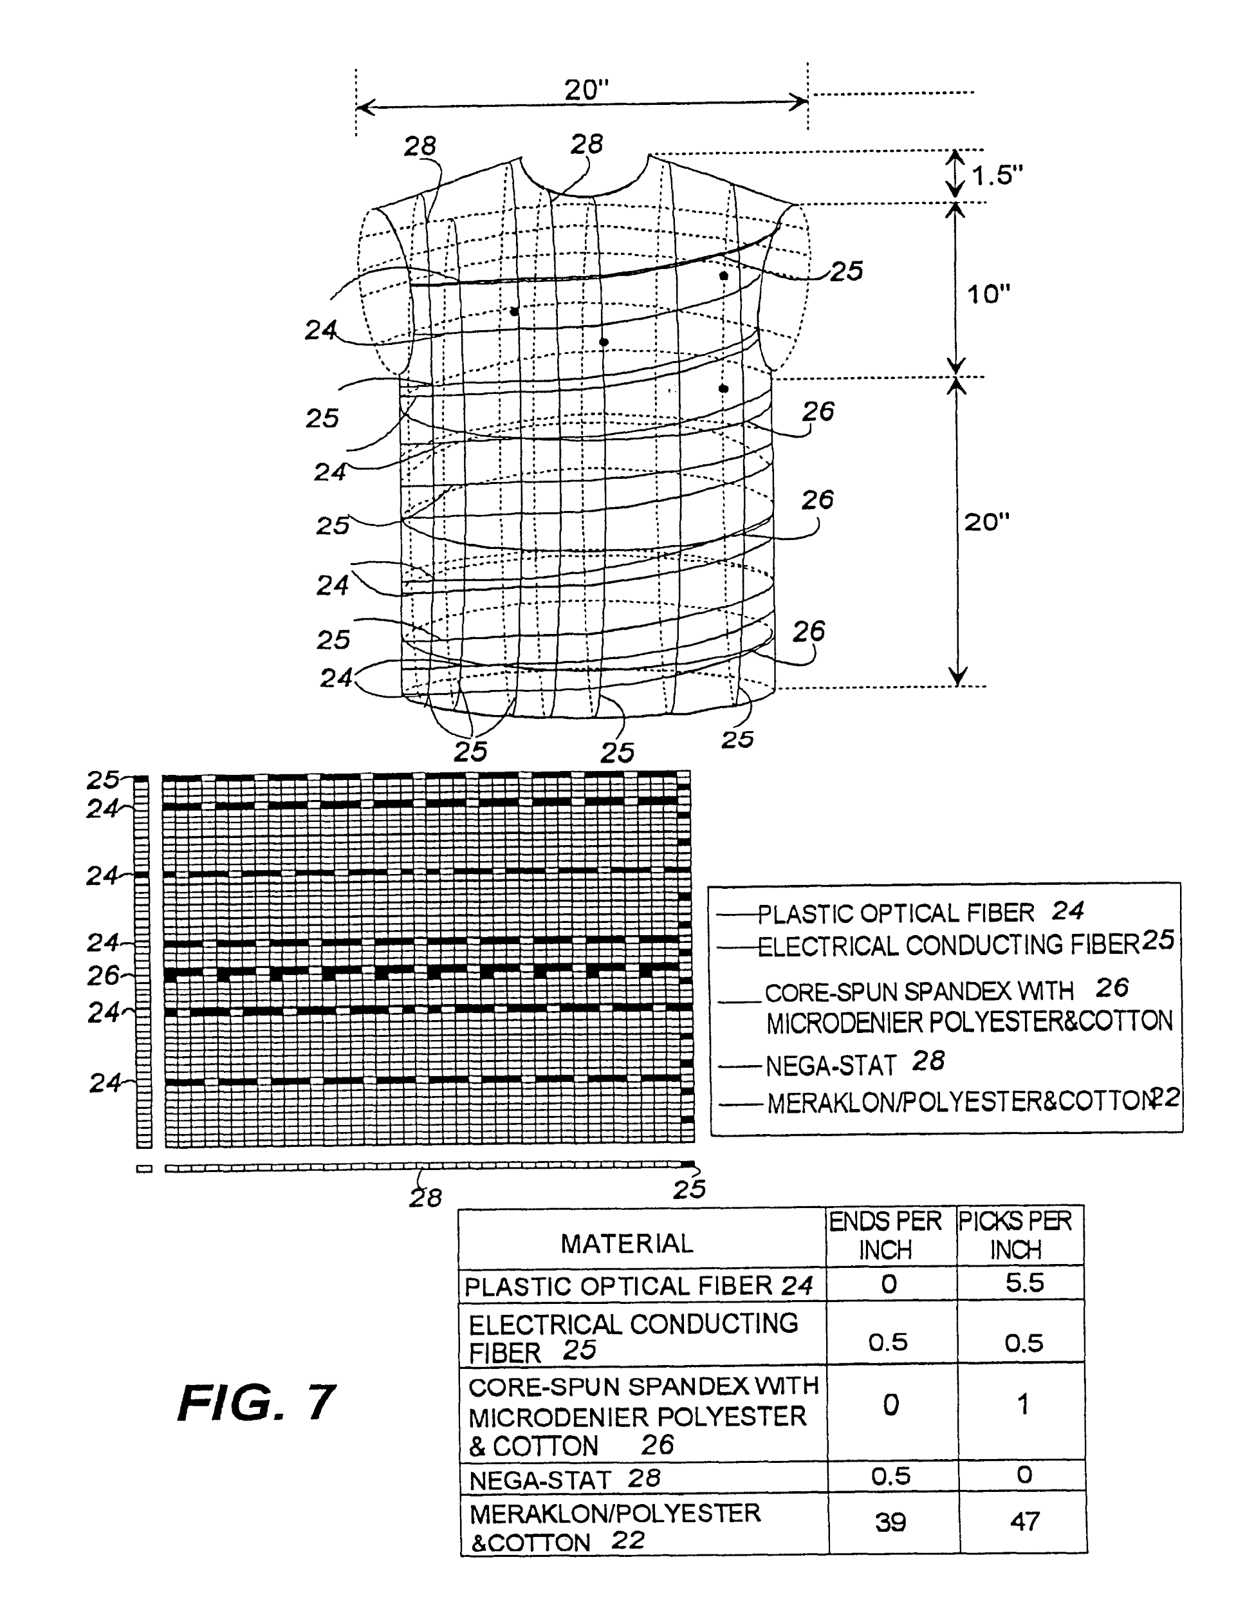

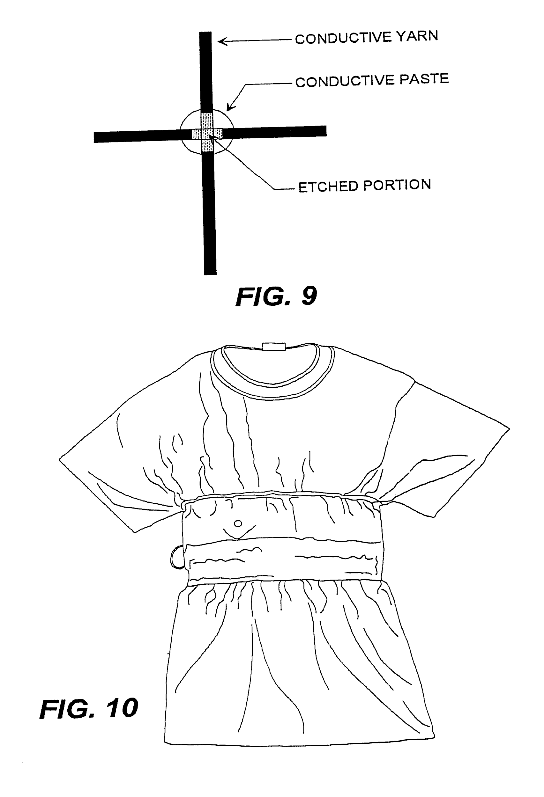

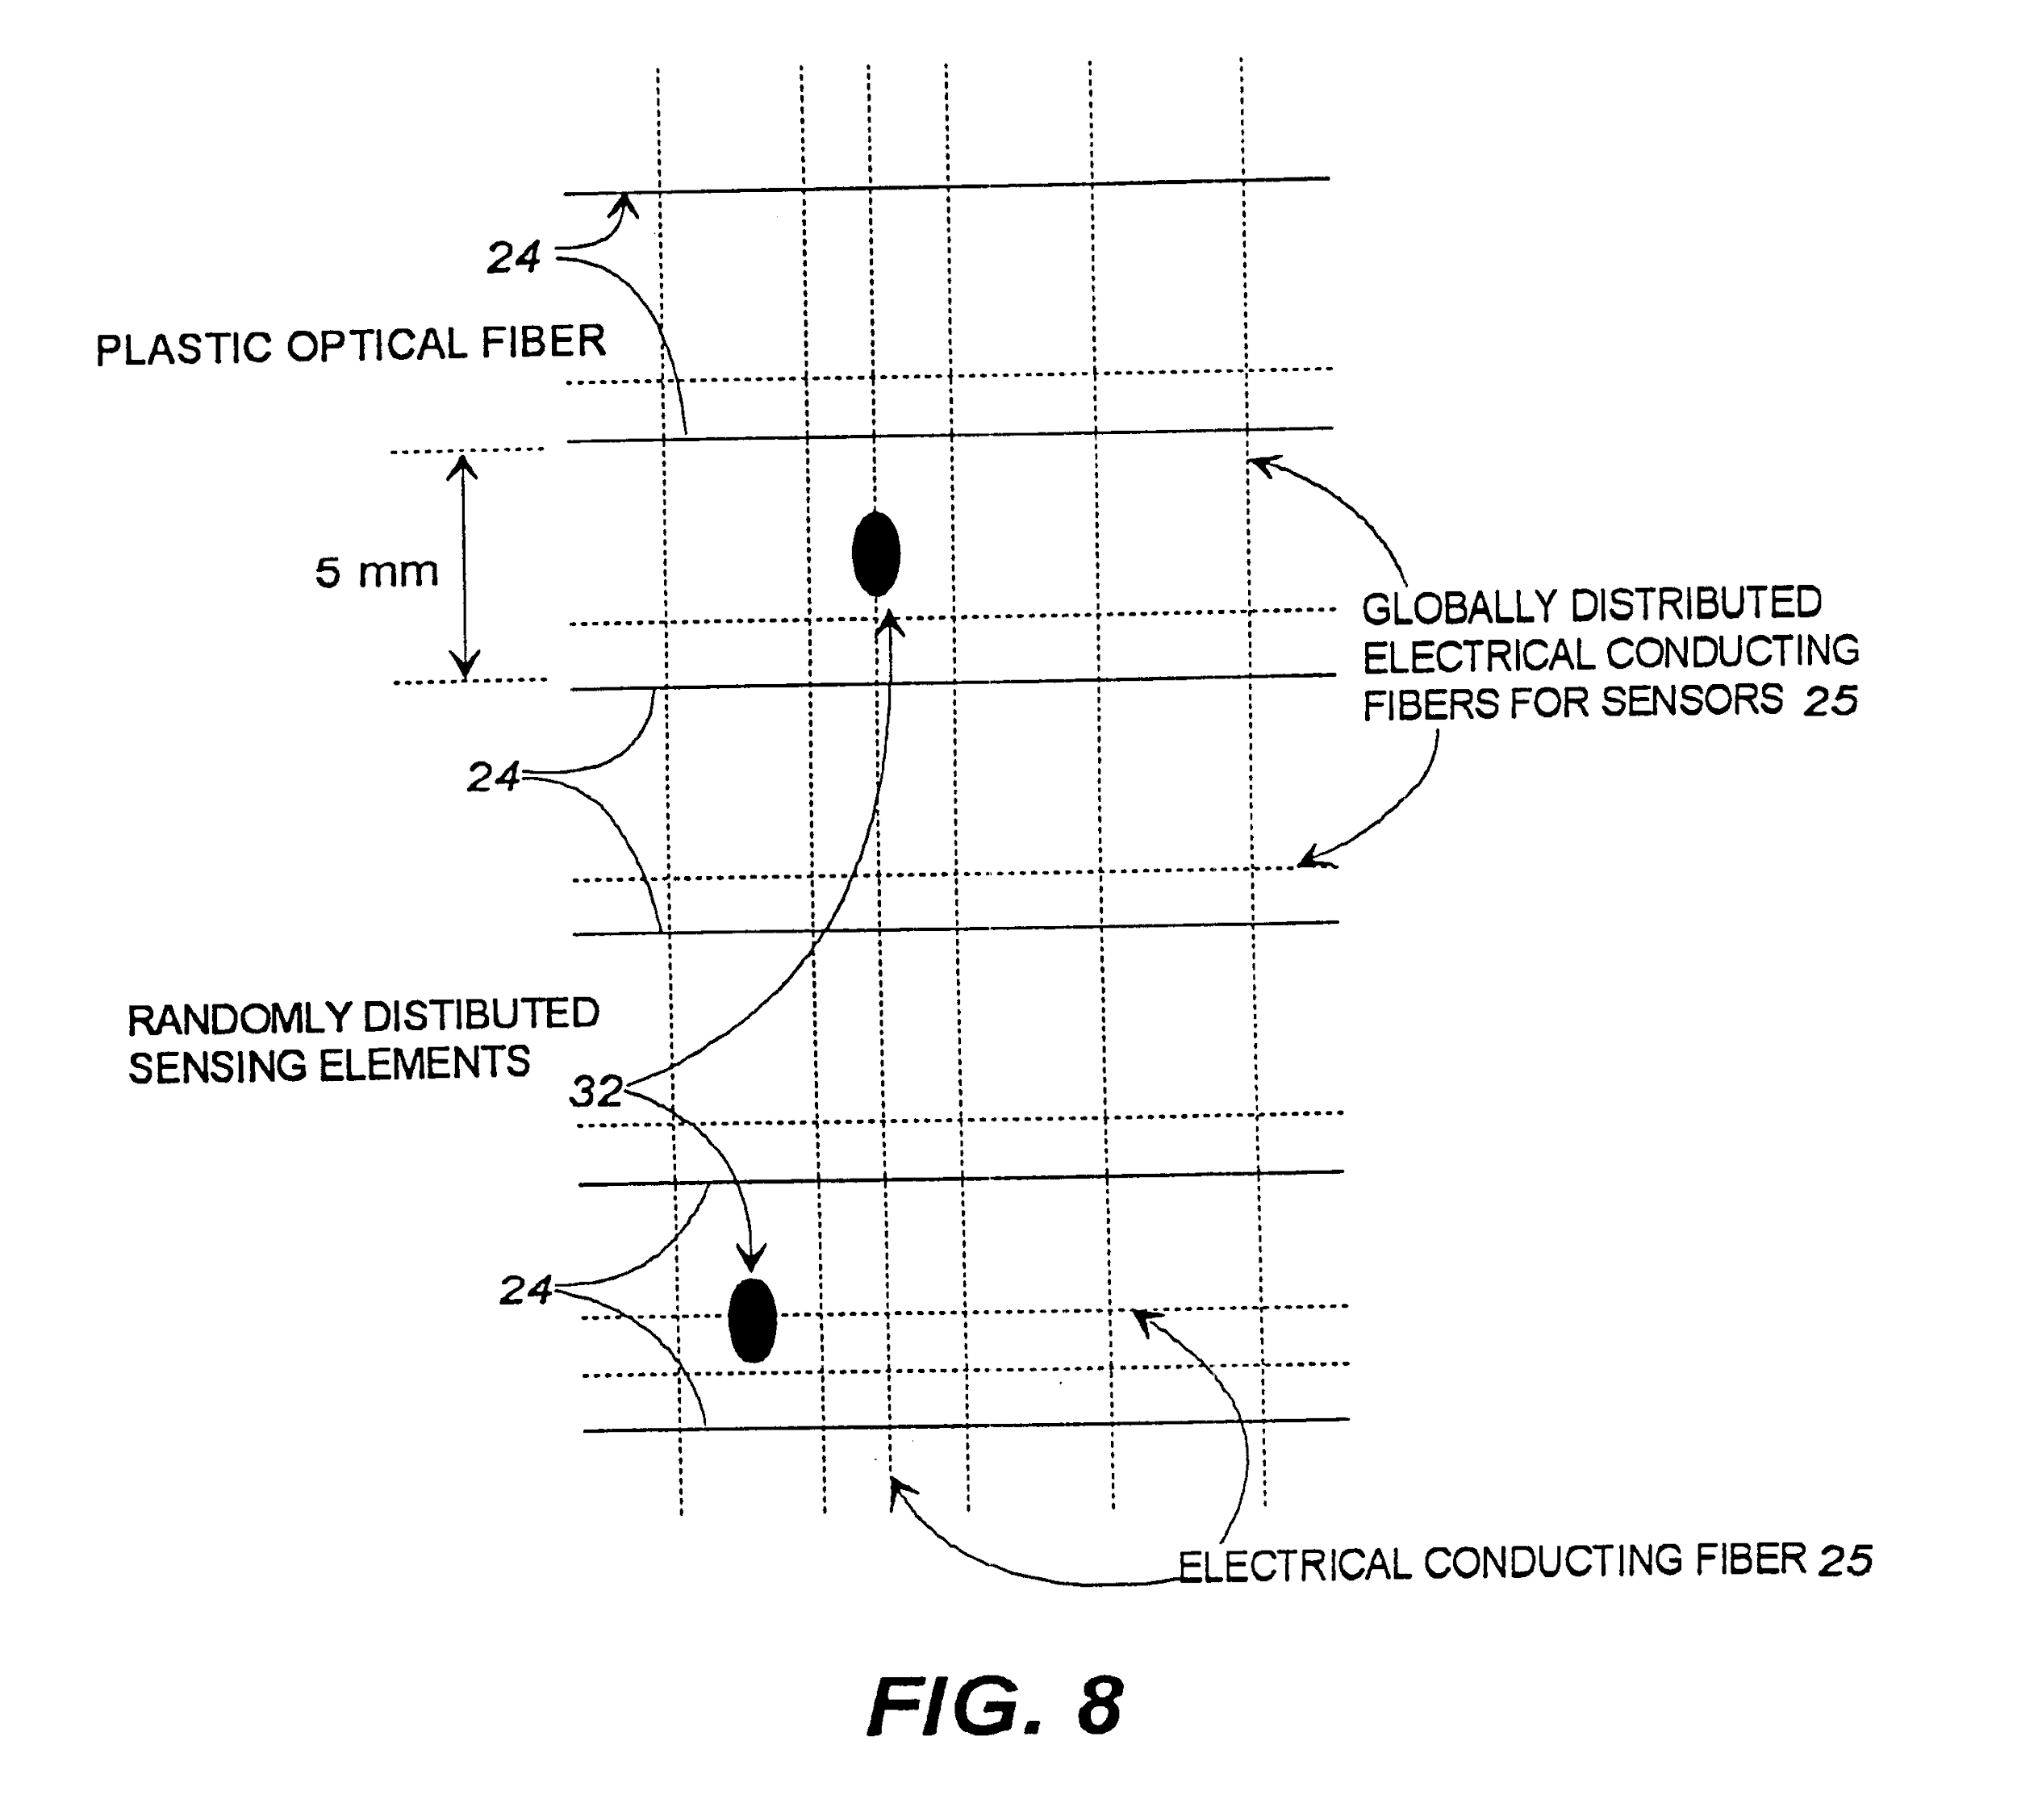

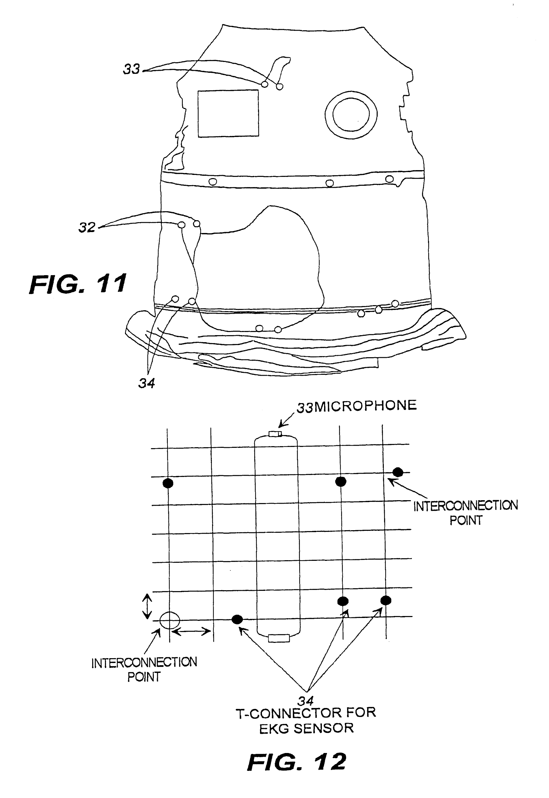

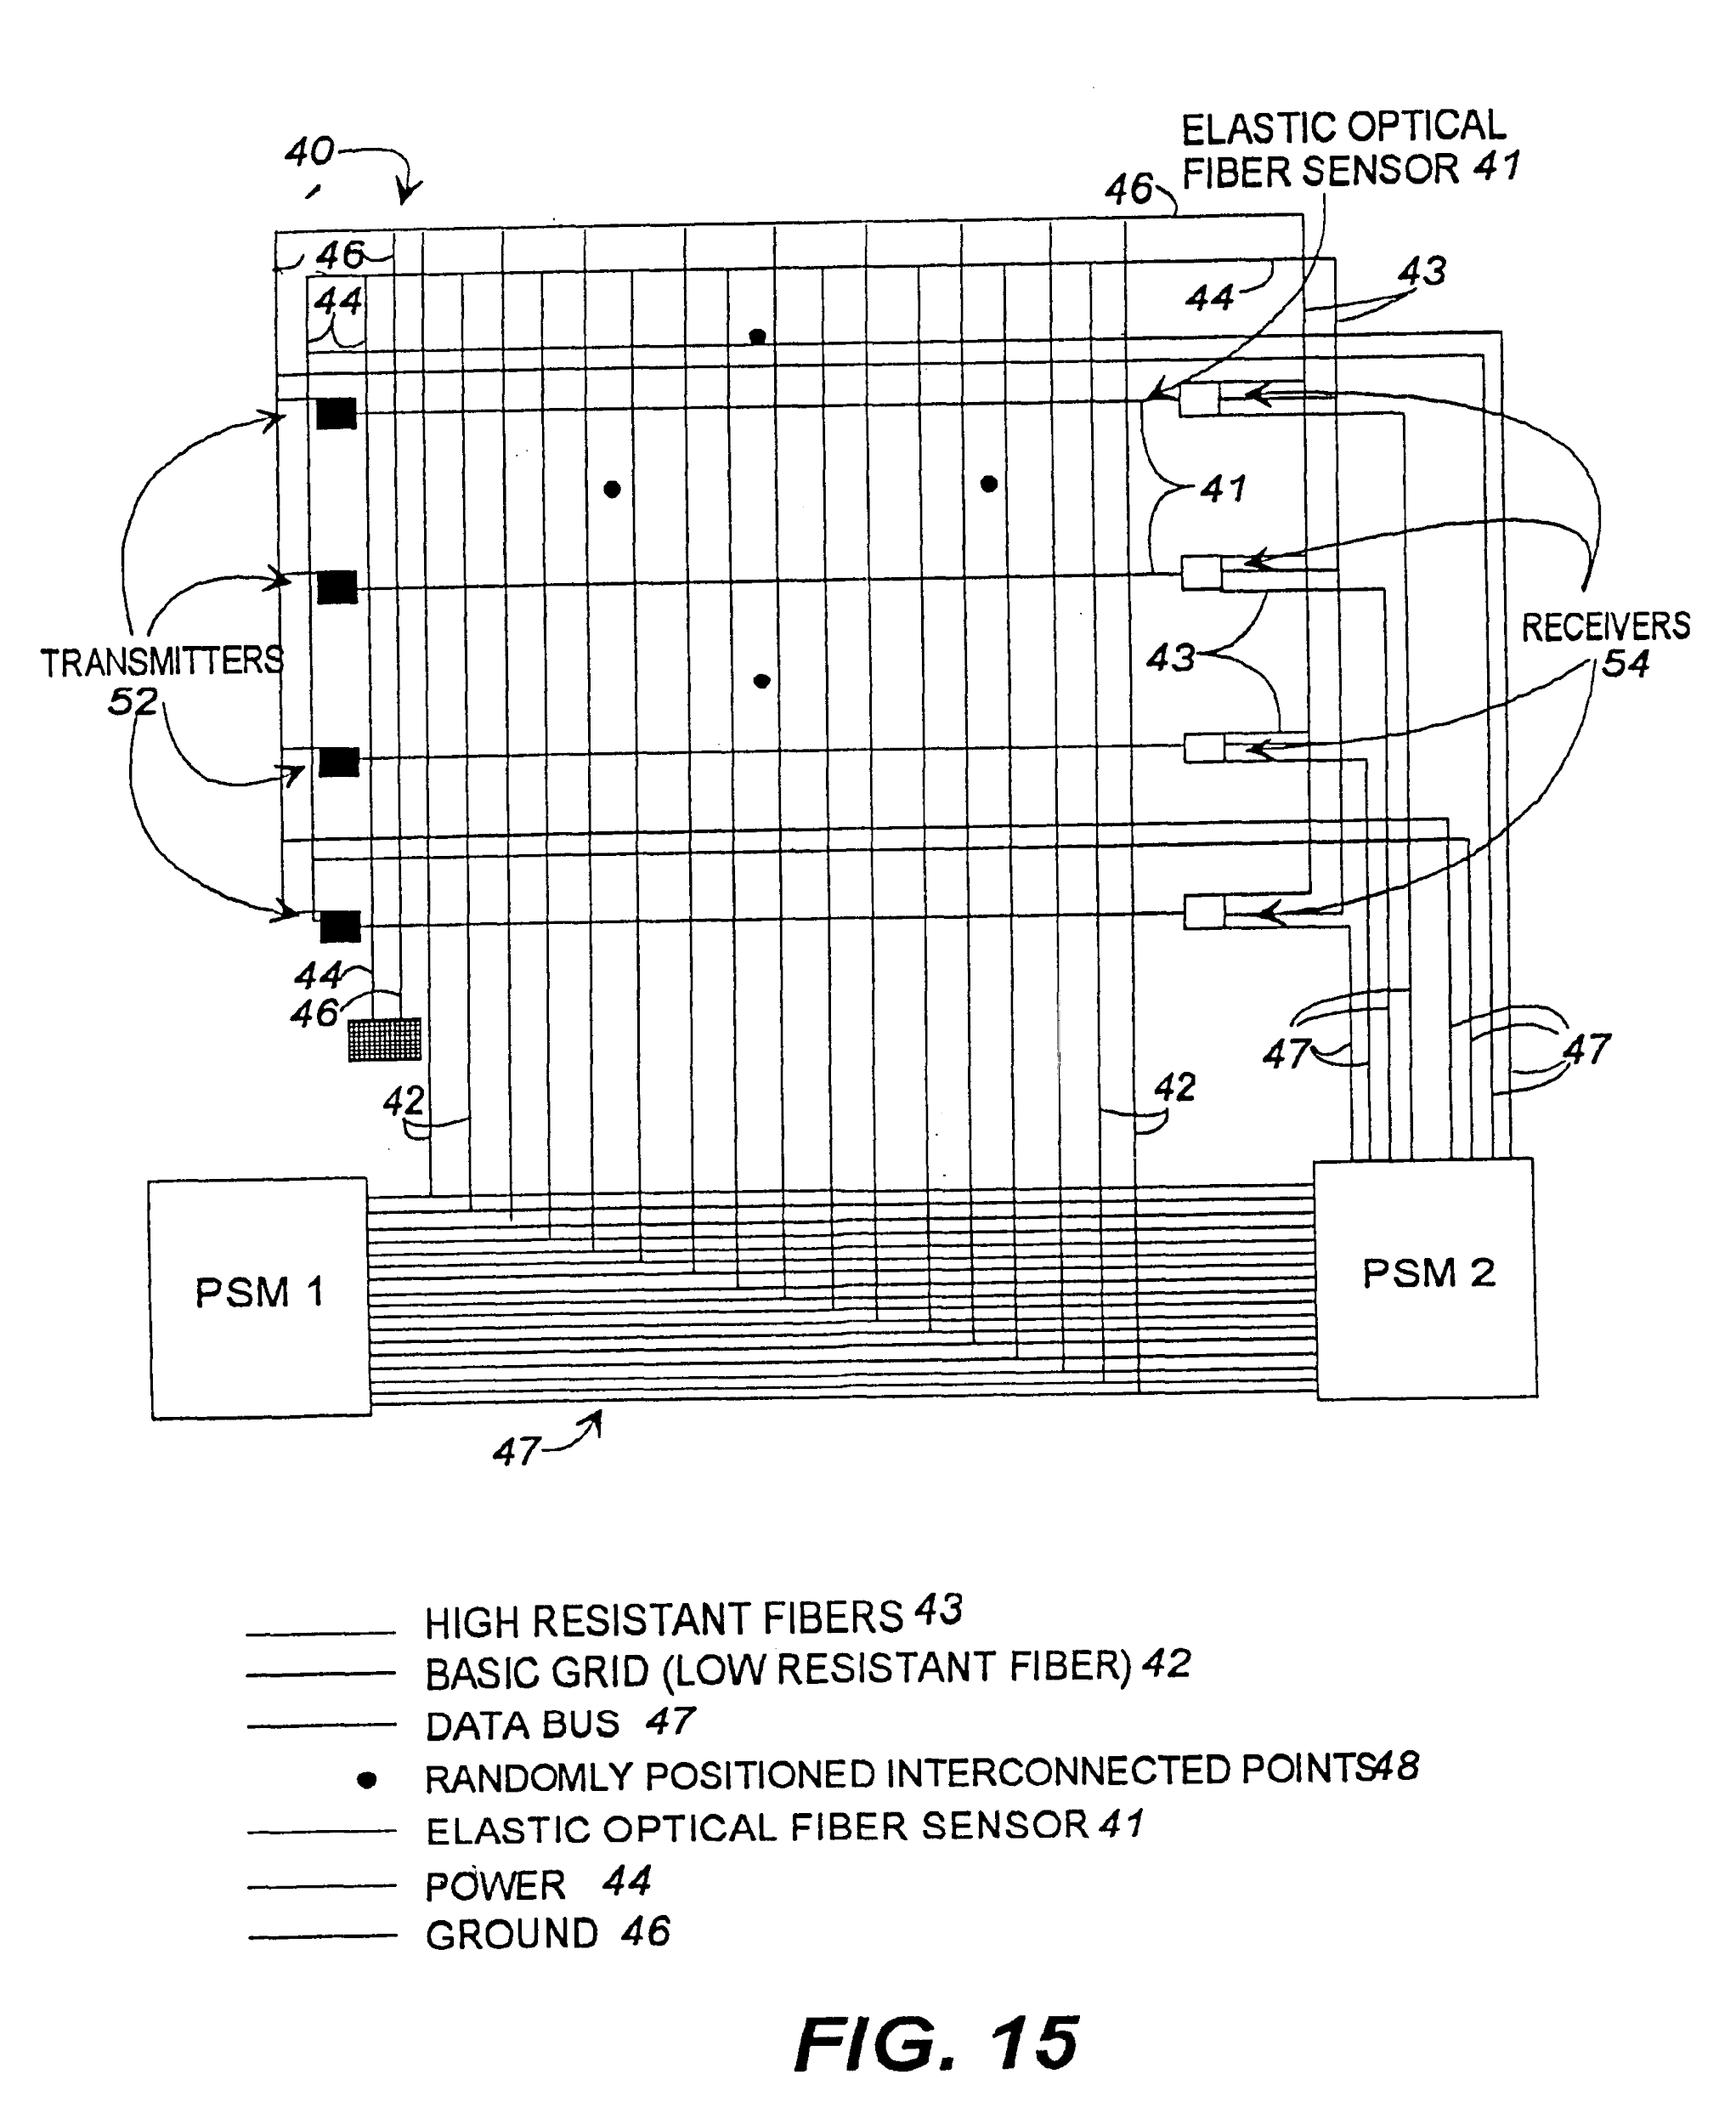

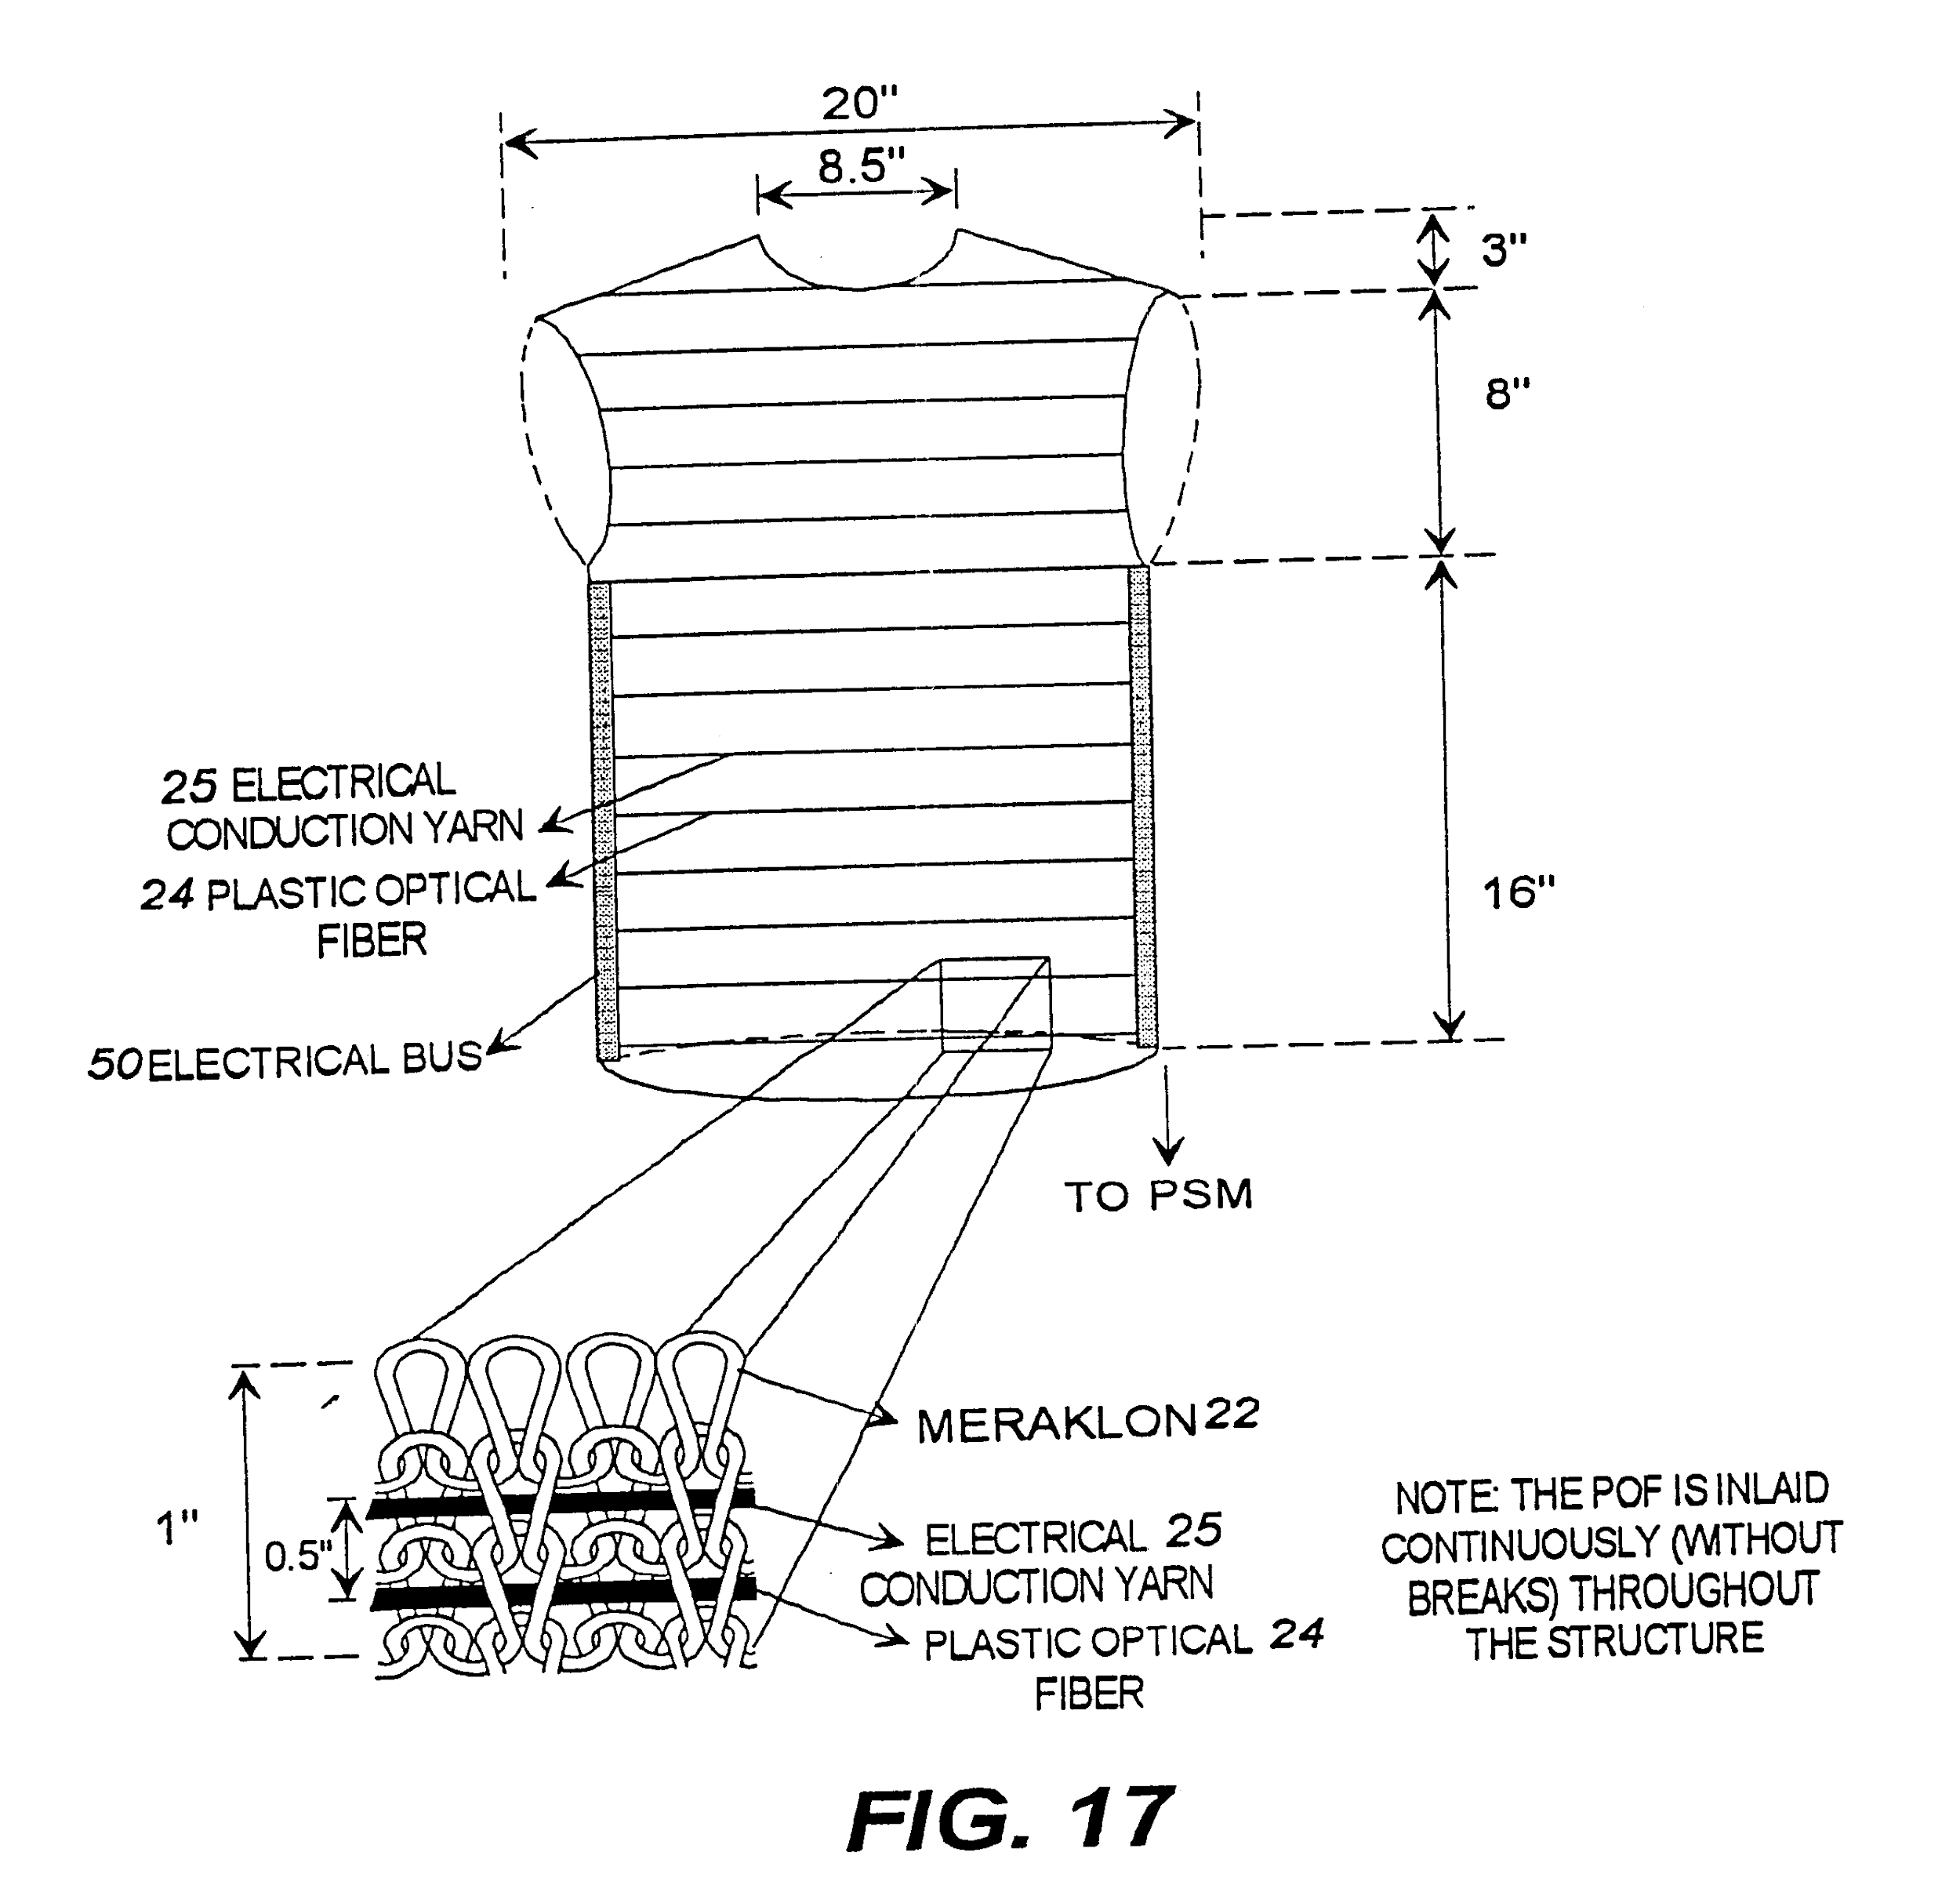

**FIG. 1 is a front elevational view of a garment into which the wearable fabric with integrated information infrastructure of the present invention has been incorporated.**

**FIG. 2 is a front elevational view of another variation of a garment into which the integrated information infrastructure of the present invention has been incorporated.**

**FIG. 3 illustrates a portion of a garment including the integrated information infrastructure according to one embodiment of the present invention;**

**FIG. 4 illustrates a portion of a garment including the integrated information infrastructure according to a second embodiment of the present invention;**

**FIG. 5 a portion of a garment including the integrated information infrastructure according to a third embodiment of the present invention;**

**FIG. 6 illustrates a portion of a garment including the integrated information infrastructure according to a fourth embodiment of the present invention;**

**FIG. 7 illustrates a further embodiment of the present invention including the information infrastructure fashioned into a wearable garment;**

**FIG. 8 illustrates the distribution of sensors in the garment of FIG. 7;**

**FIG. 9 illustrates another aspect of the present invention, namely, the interconnection of intersecting electrically conductive fibers in fabric of a preferred embodiment of the present invention;**

**FIG. 10 illustrates a garment incorporating the fabric of the present invention onto which a T-connector has been connected to electrically conductive fibers using the interconnection technology of FIG. 9 and to which an EKG sensor has been attached;**

**FIG. 11 illustrates a full-fashioned garment with a temperature sensor and microphone integrated using T-connectors according to the present invention;**

**FIG. 12 illustrates a detailed view of the results of using the interconnection technology of FIG. 9 of the present invention;**

**FIG. 13 illustrates an EKG trace taken from an EKG sensor incorporated into the garment of FIG. 10;**

**FIG. 14 illustrates a woven sample of the fabric of FIG. 7;**

**FIG. 15 illustrates the invention of FIG. 7 in the form of a printed elastic board;**

**FIG. 16 illustrates a woven fabric of the present invention integrated with sensors;**

**FIG. 17 illustrates a knitted sample of the present invention;**

**FIG. 18 illustrates an opened out illustration of the garment of FIG. 17;**

**FIG. 19 is a front view of a knitted fabric according to one embodiment of the present invention;**

**FIG. 20 illustrates one style of attachment for the invention of FIG. 19; and**

**FIG. 21 illustrates another style of attachment for the invention of FIG. 19.**

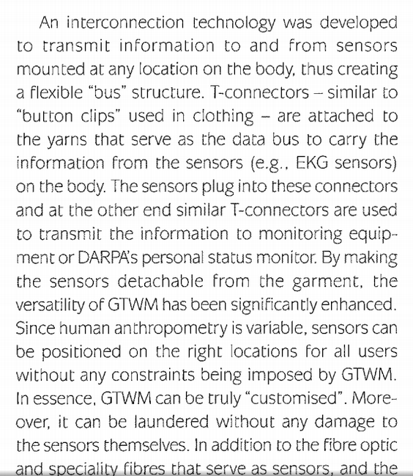

**4. ADVANCING THE PARADIGM:**

**RECENT RESEARCH**

**While the interconnection technology in GTWM facilitates the “routing” of information (i.e., signals) from any point to any other point on the wearable motherboard, the data paths are pre-determined. To realize the concept of a “programmable” computing device as an integral part of the fabricigarment in which “the fabric is the computer,” there is a need to design and develop the architecture for the wearable motherboard that would seamlessly integrate the hardware, software and softwear (fabricigarment) components or building blocks of the system. Such an architecture will facilitate the real-time reconfiguration of the system ‘building blocks’ that would lead to the realization of a truly adaptive and responsive wearable computational fabric system thus resulting in pervasivehvisible information Research is being carried out to explore the feasibility of creating such an E-Textile to demonstrate PMIP using the wearable motherboard. As the first step, the information from one or more sensors (e.g., electrocardiogram or voice) is being routed through the “soft” interconnects in the fabric to the desired output points A “switchbox“ approach has been chosen to combine the conductive fibers of an E-Textile into a programmable network. The switchbox approach is to treat the conductive fibers like the wiring resources in an FPGA to which switching components can be added at strategic intersections. A key problem in the switchbox architecture is to tolerate loose manufacturing tolerances since it is not known in advance as to which wires are connected to which pins on the switchbox. Therefore, we suggest a design for a single-chip, integrated switchbox and, simultaneously, build a demonstration prototype using off-the-The architecture consists of conductive fibers in the fabric plus switchboxes, which are affixed (like buttons) atop intersections of The manufacturing tolerance for placement of switchboxes can be a. Exact: switchboxes placement tolerance could be good enough to place switchbox contacts atop particular conductive**

**fibers. This option requires precise manufacturing b. Close: the placement tolerance is a small factor larger than the Since one of the overall objectives of this research is to produce such E-Textiles in a typical manufacturing environment, option (b) has been chosen since it is similar to fastener placement in apparel manufacturing. We assume that a switchbox covering several fibers can be placed such that it will contact a particular fiber but we do not know which switchbox contact will actually 4.2.2 Complexity of Wiring The conductive fibers in the E-Textiles can be (continuous or cut at each switchbox. a. Continuous fibers are easily manufactured. b. Cut fibers lead to a richer interconnect with higher local bandwidth between points in the fabric. From a manufacturing standpoint, option (a) is easier and so fibers (yams) that are continuous in the fabric have been chosen. We address restricted bandwidth by making the switchboxes more capable. 4.2.3 Complexity of Switchboxes Switchboxes can be built at rnultiple “grain” sizes, i.e., how much**

**computing resources are concentrated at the intersection of two fibers. We distinguish grain sizes based on the extent to which the switchbox component participates in topology discovery and**

**configuration. Minimalist, e.g., a single transistor or gate at a single intersection: configuration is managed and performed externally although configuration state may be stored at the intersection, e.g., using technology analogous to floating gates in VLSI. Communication-capable: the switchbox can communicate with, and perform local configuration on behalf of, an external agent. Global configuration is managed externally. Self-configuration-capable: the switchbox contains enough**

**processing power to participate in a distributed, global configuration algorithm. We chose option (b), switchboxes capable of self-configuring to the point of establishing co~munication with an external agent which then manages global configuration. Thus, we chose an architecture for the computational fabric in which the electronic elements are of moderate capability, are placed deliberately, but inexactly, and without making cuts in the fabric.**

**4.3 Technical Issues and Decisions’**

**We have identified three k1:y issues with our architecture and proposed solutions for them. They are: power distribution, configuration information distribution and autoinatic discover{ of topology.**

**4.3.1 Power Distribution**

**Power distribution is difficult with inexact placement of components because power connections are usually distinguished from signal connections. We believe it may be possible to power ordinary integrated circuits via any pin using diode structures similar to existing static discharge protection structures. However, for the first demonstration prototype, we use distinguished power wires in the fabric by providing enough spacing to account for our placement tolerance (unlike signal wires).**

**Figure 3. Prototype board, 2.8”x1.8”, containing the FPGA and microcontroller. Site-specific sensorleffectorlcommunication devices attach as “daughtercards.” The chosen FPGAs were physically integrated into the fabric (see Figure 4). Software was developed to demonstrate the “in-fabric’’ network. One of the FPGAs communicated with an external agent (a Linux-based personal computer) that was responsible for managing the global configuration of the FPGAs in the fabric by sequencing the “discovery” in the fabric beginning with that initial FPGA.**

**Figure 4. The PMIP Network in a Fabric Two software modules were created; the first was to “demonstrate” the pin-connection discovery algorithm implemented in the system to identify the connections between the various pins on the FPGAs in the fabric and to display the connection paths. This enables discovery of the interconnects on the fly after the manufacturing has been carried out and there is no a priori knowledge of the specific connections between the elements in the fabric. The second module discovers the connections and displays the paths on the screen as the discovery process proceeds when the FPGA is powered. To demonstrate the flow of information in the fabric network through the soft interconnects, a potentiometer was attached as a daughterboard to one of the FPGAs and whenever it was “twiddled” (see Figure 4), the resulting change is displayed on the screen (Figures 5 and 6). This recent effort demonstrates the feasibility of realizing a programmable network in a fabric through soft interconnects and paves the way for the continued exploration of the “fabric is the computer” paradigm pioneered by the Georgia Tech Wearable Figure 6. Flow of Information through the PMIP Fabric.**

**CONCLUDING REMAR!KS A well-designed information processing system should facilitate**

**the access of information Anytime, Anyplace by Anyone -- the three As. The ‘ultimate’ information processing system should not only provide for large bandwidths, but also have the ability to see, feel, think, and act. In other words, the system should be totally**

**‘customizable’ and be in tune with the human. Of course, clothing is probably the only e1emen.t that is ‘always thcre’ and in complete harmony with the individual (at least in a civilized society!). And, textiles provide the ultimate flexibility in syst8:m design by virtue of the broad range of fibers, yams, fabrics, and manufacturing techniques that can be deployed to create products for desired**

**end-use applications. A new avenue of research and exploration has opened up for the development of an integrated “textilecomputing” system that can serve as a true information processing framework with the ability to sense, feel, think and act based on the end-user stimuli and/or the operational environment. This “fabric is the computer” paradigm exemplified by the Georgia Tech Wearable Motherboard demonstrates the feasibility of realizing personalized mobile information processing (PMIP) and gives new meaning to the term human-machine symbiosis in the context of pervasivelinvisible computing.**

**RFID for data transfer:** [**http://www.impinj.com/resources/about-rfid/the-different-types-of-rfid-systems/**](http://www.impinj.com/resources/about-rfid/the-different-types-of-rfid-systems/)

**Batteryless circuit:**[**http://www.ncbi.nlm.nih.gov/pubmed/25123466**](http://www.ncbi.nlm.nih.gov/pubmed/25123466)

**Look into this:**

[**https://www.clear.rice.edu/elec201/Book/sensors.html**](https://www.clear.rice.edu/elec201/Book/sensors.html)

[**http://www.edn.com/design/test-and-measurement/4420987/Sensor-basics--Types--function-and-applications**](http://www.edn.com/design/test-and-measurement/4420987/Sensor-basics--Types--function-and-applications)

[**http://en.wikipedia.org/wiki/Sensor_node**](http://en.wikipedia.org/wiki/Sensor_node)